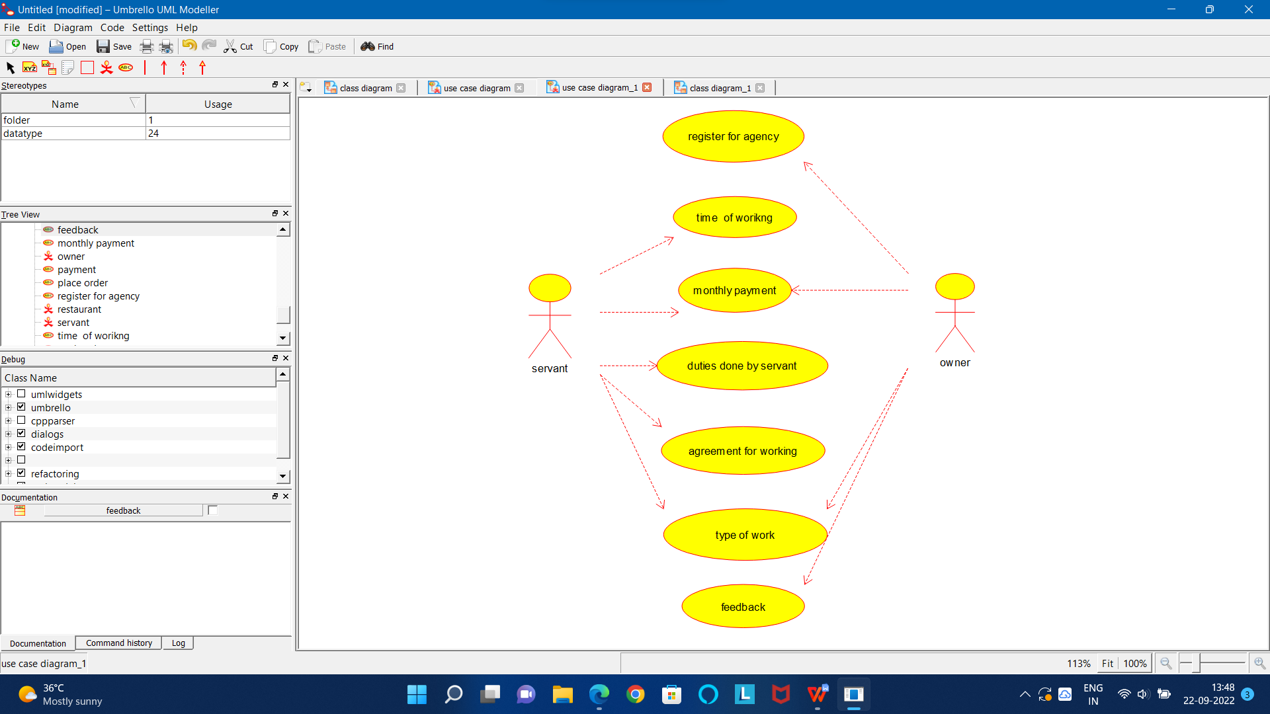

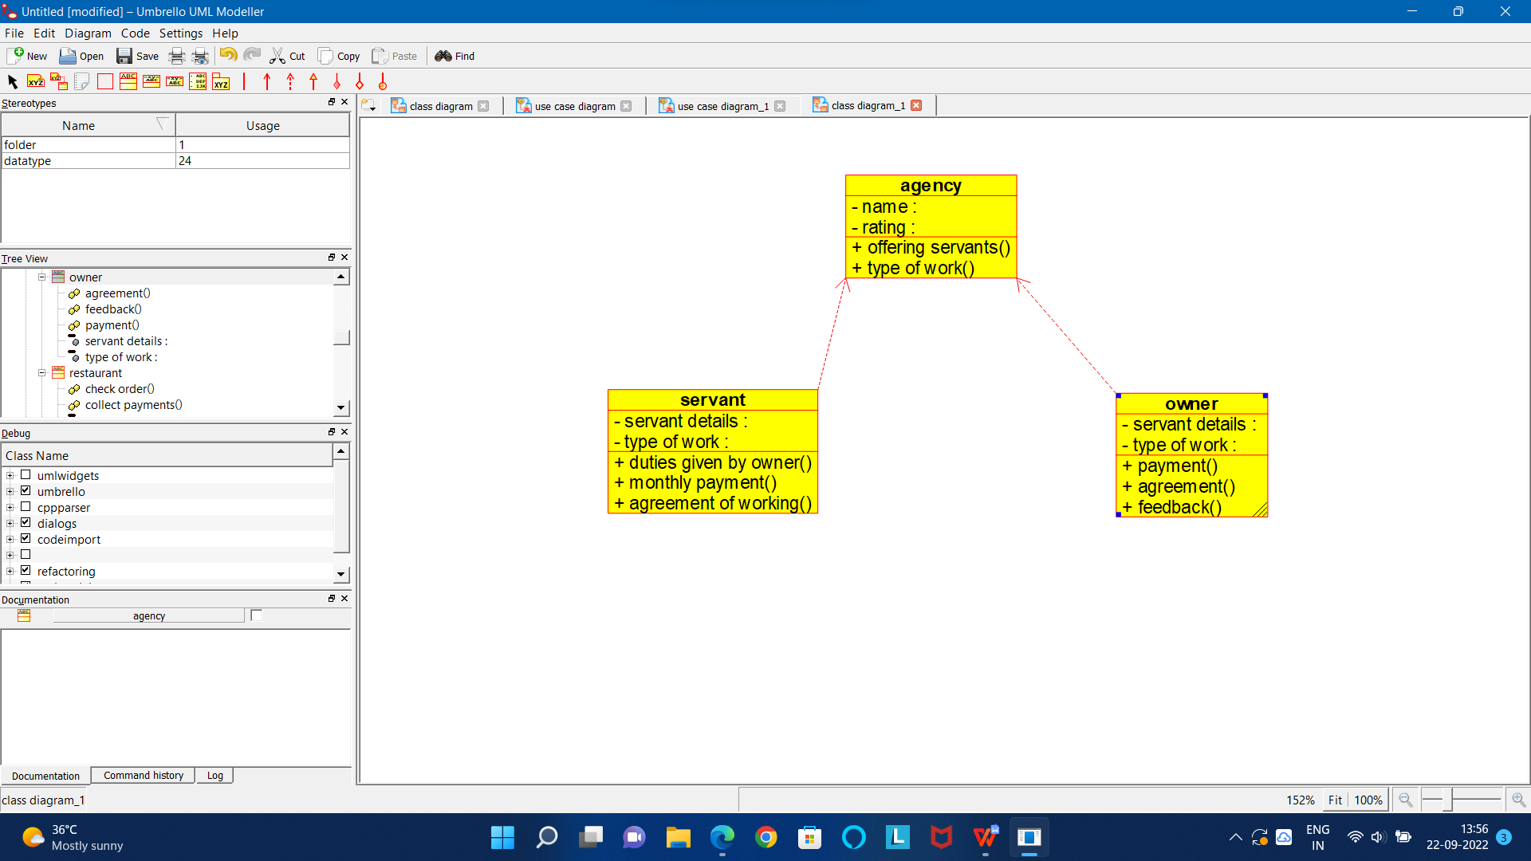

CODE FOR AGENCY:

/**

* Class agency

*/

public class agency {

//

// Fields

//

private void name;

private void rating;

//

// Constructors

//

public agency () { };

//

// Methods

//

//

// Accessor methods

//

/**

* Set the value of name

* @param newVar the new value of name

*/

private void setName (void newVar) {

name = newVar;

}

/**

* Get the value of name

* @return the value of name

*/

private void getName () {

return name;

}

/**

* Set the value of rating

* @param newVar the new value of rating

*/

private void setRating (void newVar) {

rating = newVar;

}

/**

* Get the value of rating

* @return the value of rating

*/

private void getRating () {

return rating;

}

//

// Other methods

//

/**

*/

public void offering_servants()

{

}

/**

*/

public void type_of_work()

{

}

}

CODE FOR OWNER:

/**

* Class owner

*/

public class owner {

//

// Fields

//

private void servant_details;

private void type_of_work;

//

// Constructors

//

public owner () { };

//

// Methods

//

//

// Accessor methods

//

/**

* Set the value of servant_details

* @param newVar the new value of servant_details

*/

private void setServant_details (void newVar) {

servant_details = newVar;

}

/**

* Get the value of servant_details

* @return the value of servant_details

*/

private void getServant_details () {

return servant_details;

}

/**

* Set the value of type_of_work

* @param newVar the new value of type_of_work

*/

private void setType_of_work (void newVar) {

type_of_work = newVar;

}

/**

* Get the value of type_of_work

* @return the value of type_of_work

*/

private void getType_of_work () {

return type_of_work;

}

//

// Other methods

//

/**

*/

public void payment()

{

}

/**

*/

public void agreement()

{

}

/**

*/

public void feedback()

{

}

}

CODE FOR SERVANT:

/**

* Class servant

*/

public class servant {

//

// Fields

//

private void servant_details;

private void type_of_work;

//

// Constructors

//

public servant () { };

//

// Methods

//

//

// Accessor methods

//

/**

* Set the value of servant_details

* @param newVar the new value of servant_details

*/

private void setServant_details (void newVar) {

servant_details = newVar;

}

/**

* Get the value of servant_details

* @return the value of servant_details

*/

private void getServant_details () {

return servant_details;

}

/**

* Set the value of type_of_work

* @param newVar the new value of type_of_work

*/

private void setType_of_work (void newVar) {

type_of_work = newVar;

}

/**

* Get the value of type_of_work

* @return the value of type_of_work

*/

private void getType_of_work () {

return type_of_work;

}

//

// Other methods

//

/**

*/

public void duties_given_by_owner()

{

}

/**

*/

public void monthly_payment()

{

}

/**

*/

public void agreement_of_working()

{

}

}